Print Out Source Code Program

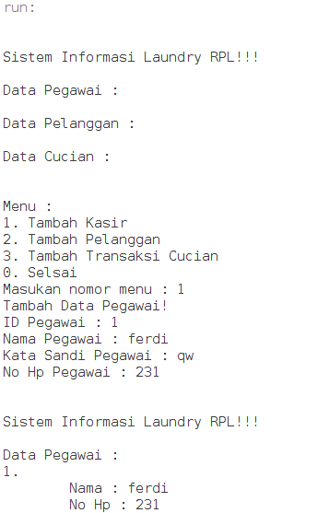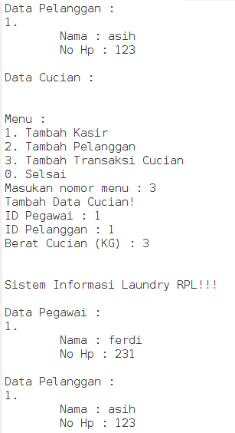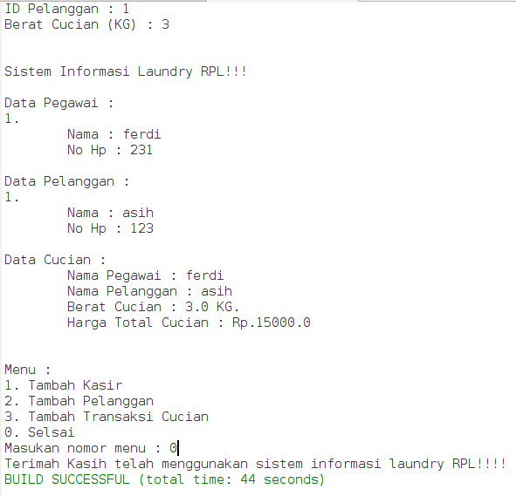

Keterangan Source Code :

-----------------------------------------------------------------------------------------------------------------------------------------------------------------------------------------------------------------------------------------------------------------------------------------------------------------------------------------------------------------------------------------------------------------------------------------------------------------------------------------------------------------------------------------------------------------------------------------------------------------------------------------------------------------------------------------------------------------------------------------------------------------------------------------------------------------------------------------------------------------------------------------------------------------------------------------------------------------------------------------------------------------------------------------